**DAILY ONLINE ACTIVITIES SUMMARY**

|  |  |  |  |  |  |  |  |  |
| --- | --- | --- | --- | --- | --- | --- | --- | --- |
| **Date:** | 01-06-2020 | | | | | **Name:** | K S Prajwal | |
| **Sem & Sec** | Vi A sec | | | | | **USN:** | 4AL18CS032 | |
| **Online Test Summary** | | | | | | | | |
| **Subject** | | Complex analysis, probability and statistical methods | | | | | | |
| **Max. Marks** | | 30 | | **Score** | | | 20 | |
| **Certification Course Summary** | | | | | | | | |
| **Course** | **Python and Django Full Stack Web Developer Bootcamp** | | | | | | | |
| **Certificate Provider** | | | Udemy | | **Duration** | | | **3 hr** |
| **Coding Challenges** | | | | | | | | |
| **Problem Statement:** 1. Calculating nPr value  2. Finding subarrays of an array based on certain condition | | | | | | | | |
| **Status:** completed | | | | | | | | |
| **Uploaded the report in Github** | | | | | yes | | | |
| **If yes Repository name** | | | | | <https://github.com/alvas-education-foundation/KS_Prajwal> | | | |
| **Uploaded the report in slack** | | | | | yes | | | |

Online Test Details: (Attach the snapshot and briefly write the report for the same)

Certification Course Details: (Attach the snapshot and briefly write the report for the same)

Coding Challenges Details: (Attach the snapshot and briefly write the report for the same)

**Online Test Details:**

The online test was from module 5 which was about joint probability distribution and sampling theory. There were 20 questions where 10 was for 1 mark each and the remaining 10 for 2 marks each and the duration was 45 minutes. The questions were optimal and were easy. The score that I got in the test is 20/30.



Snapshot of certification course:



it was about advance html i.e. Tables, basics of form, different input methods, labels, and there was an assessment.

**Online coding:**

Problem 1: (using JAVA) Write a Java program to calculate nPr.

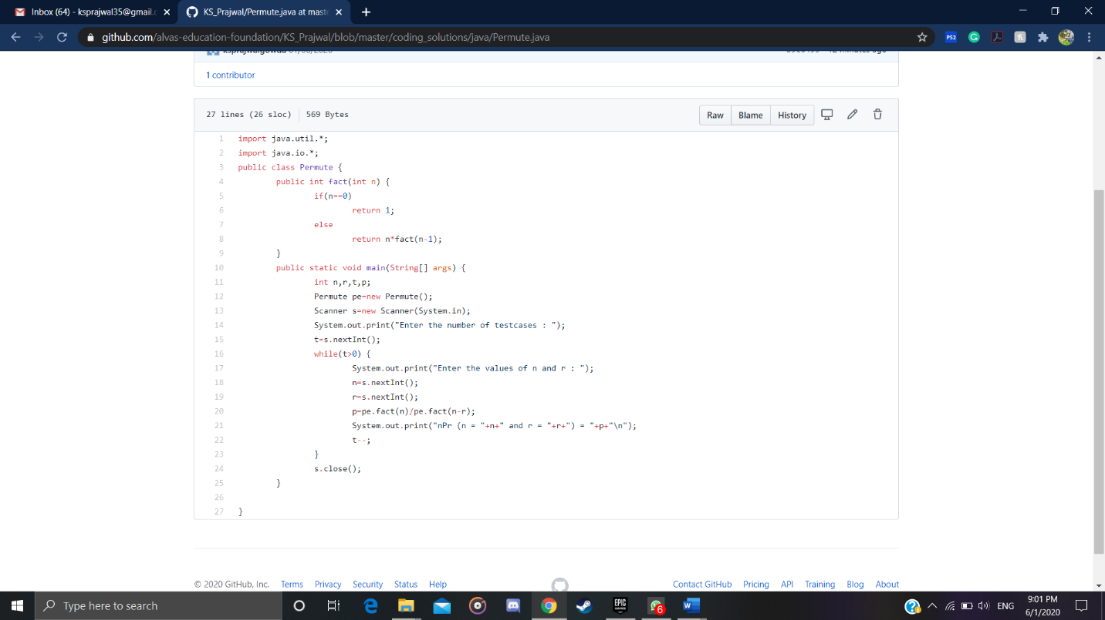

Problem 2: (using JAVA) Given an array arr[] of size N and an integer K. The task is to find the count of subarrays such that each subarray has exactly K distinct elements.

